**WEB-X CA PREREQUISITES DONOR CONNECT**

|  |  |
| --- | --- |
| Name of Student | **Omkar Gholap** |
| Class Roll no | **D15A-17** |
| D.O.P | **20.03.25** |
| D.O.S | **27.03.25** |
| Sign and Grade |  |

**Introduction:**

With the increasing need for personal health management, digital solutions for fitness tracking have become essential. This project aims to provide users with an integrated platform to monitor their nutrition and exercise, set and achieve fitness goals, and visualize progress. **System Requirements:**

1. **Hardware Requirements:** 
   * **Processor:** Intel Core i5 or higher

* + **RAM:** Minimum 8GB (Recommended: 16GB)

* + **Storage:** At least 10GB of free disk space

* + **Operating System:** Windows 10/11, macOS, or Linux

1. **Software Requirements:** 
   * **Node.js (v18.16.1 or later)** – For running the React frontend

* + **npm (v9.5.1 or later)** – To manage frontend dependencies

* + **Python (3.11.9 or later)** – For the Flask backend

* + **MongoDB Atlas** – Cloud-based NoSQL database

* + **VS Code** – Recommended IDE for development

* + **Postman** – For testing REST APIs

**Technology Stack:**

1. **Frontend:** 
   * **React.js** – JavaScript library for building user interfaces

* + **Tailwind CSS** – Utility-first CSS framework for rapid styling

1. **Backend:** 
   * **Flask** – Lightweight Python-based web framework

* + **Flask-CORS** – Handle Cross-Origin Resource Sharing

* + **PyMongo** – Connects Flask with MongoDB

* + **PyJWT** – Implements secure JWT-based authentication

* + **python-dotenv** – Manages secure environment variables

* + **flask-login** – Manages user sessions and secure login/logout

1. **Database:** 
   * **MongoDB Atlas** – Cloud-hosted NoSQL database to store donor and requestor data, blood requests, and responses

**Setup Instructions:**

**1. Install Node.js and NPM**

# ● Download from: [https://nodejs.org](https://nodejs.org/)

**● Verify installation:**

node -v npm -v

1. **Install Python and Flask** 
   * Download Python from: [https://www.python.org](https://www.python.org/)

* + Verify installation:

python --version

pip --version

* + Install Flask and dependencies:

pip install flask flask-cors pymongo pyjwt python-dotenv flask-limiter flask-login

1. **Setup MongoDB Atlas** 
   * Create a free MongoDB Atlas account at<https://www.mongodb.com/cloud/atlas>

* + Replace connection string in the backend .env file

* + For local setup (optional):

mongod --dbpath /path/to/data

**PROJECT STRUCTURE:**

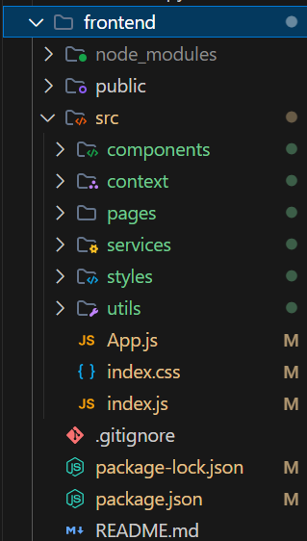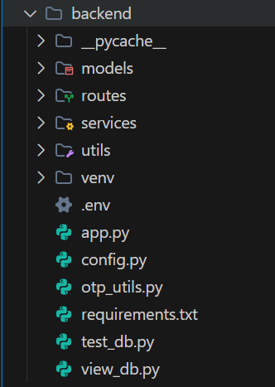

**Conclusion:**

The Fitness App successfully integrates modern web technologies to deliver a robust, user-friendly platform for fitness tracking. Future enhancements could include integration with wearable devices, social features, and advanced analytics.